The SpotCheck Studio Plugin

The SpotCheck plugin marks a randomly selected number of segments in a Studio document. It's intended to be make it easier to spot-check machine translated files.

# Installation

* Make sure Studio is closed.
* Run *setup.exe*.
* Start Studio: it warns you about an unsigned plugin, accept. (The final version will be signed)
* That's it, the plugin is installed.
* To remove, use the *Uninstall Program* list from the Windows *Control Panel/Programs and Features*).

# How to use

## Select segments to check

* Open Studio with the project you want to spot-check, and choose the *Files* view. A new tab, SDL SpotCheck, is available.  
  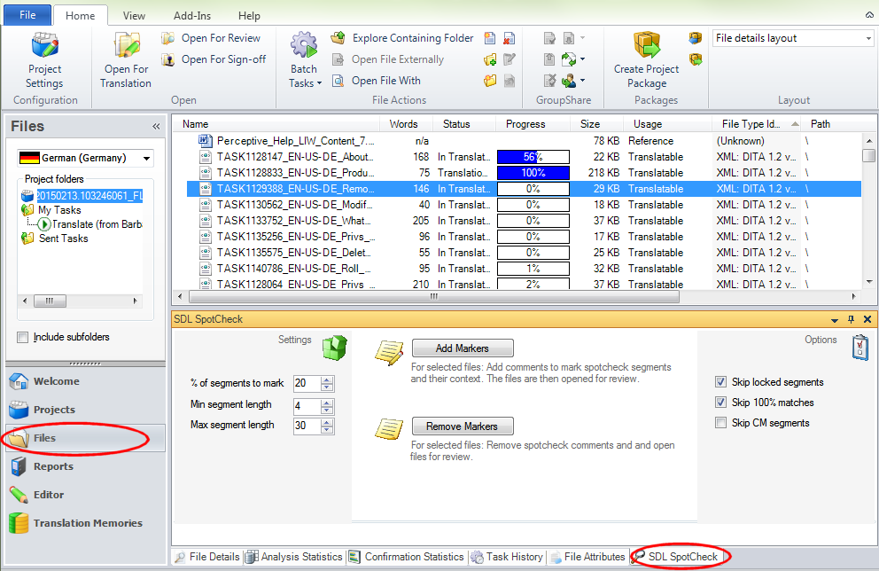
* Select the files that you want to work with, change the Settings and options if required, and click the *Add Markers* button. This will add source comments to a number of segments, and then open the modified file(s) in the Editor for review.
* Note: if you are not sure if you have added markers, just try, the plugin will detect existing markup and not do it again. A message will notify you of skipped files.

## Settings and Options

* **% of segments to mark**: defines what percentage of total segments should be spot checked
* **Min segment length**: segments that are shorter than this (in words) are never selected
* **Max segment length**: segments that are longer than this (in words) are never selected
* **Skip locked segments**: if a segment is already locked, it won't be selected. *Note*: this option has to be selected each time you add markers. The reason is that it is an important decision if you want to check locked segments or not, so this forces you to actively decide.
* **Skip 100% matches**: if a segment is a 100% match, it won't be selected
* **Skip CM segments**: if a segment is a Context Match, it won't be selected

## Review

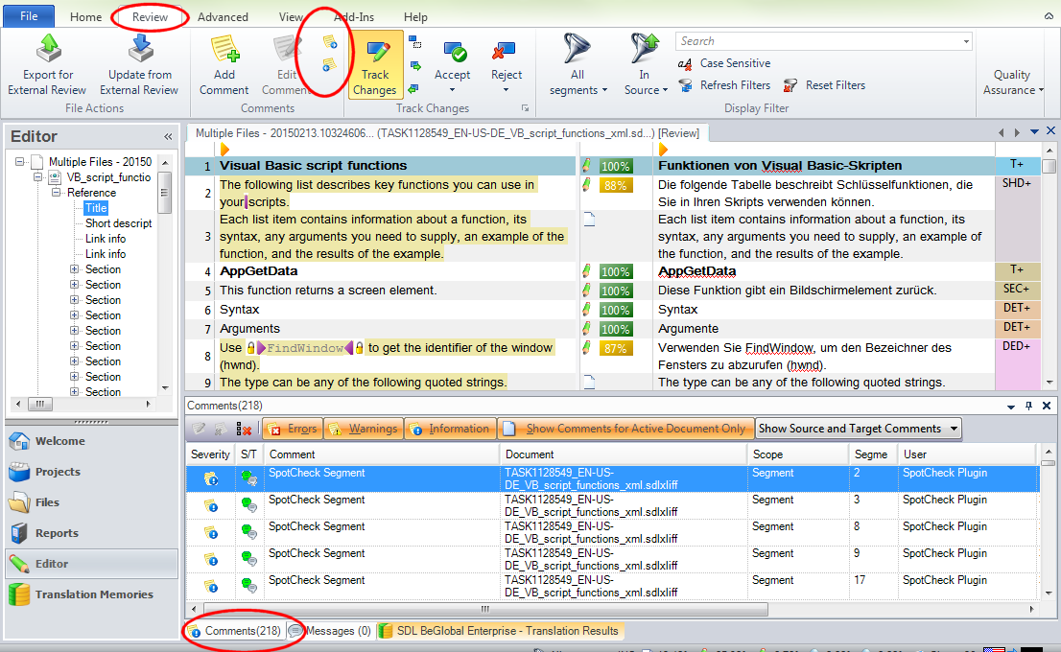The files are opened in the editor in review mode. If you selected multiple files, they are opened in one combined editor view. The screenshot shows the recommended configuration:

* Go into *Review* mode in the Ribbon
* Select the *Comments* tab in the bottom window
* Use the *Next/Previous Comment* buttons in the Ribbon to navigate between segments, or the keyboard shortcuts *Ctrl+M* and *Shift+Ctrl+M*.
* The *Comments* window shows if a comment is a SpotCheck marker or has been there before.

## Finalize files

* When you finished reviewing, get back to the *Files* view, and the *SDL SpotCheck* control.
* Select the edited files again.
* Click the *Remove Markers* button.
* The files are now in the final version, without any extra markup, but with your changes.
* Note: if you are not sure if you need to remove markers from a file, just try. The plugin will detect if a file has no markers to remove, and will do nothing. A message will notify you of skipped files.

## Known issues

* If you open an sdlxliff file that is not part of a project, you need to first switch to the project view and select the (auto-generated) project there. If you directly start adding markers, you'll get an error message.